Environmental Justice
Name
Institution Affiliations
Course Title
Date

Environmental justice is a principle that advocates for fair treatment and significant involvement of the entire community in the development, implementation, and enforcement of environmental policies, laws, and regulations. The goal of environmental justice can be achieved when everyone regardless of their race, origin, color, or social status enjoys similar levels of protection from environmental and health risks, as well as getting equal access to participate in decision-making processes involving the establishment of healthy environments which we live, work and learn in. The concept of environmental justice begun in the U.S. in the early 1980s. The term environmental justice is used to describe a social movement whose main focus is to achieve a “fair” distribution of environmental benefits as well as burdens. The concept of environmental justice can also be used as an interdisciplinary social science literature body that describes theories of the environment and justice, environmental policies and laws and how they are implemented, planning and governance for development, environmental sustainability, and political ecology, (Salem, 2019).
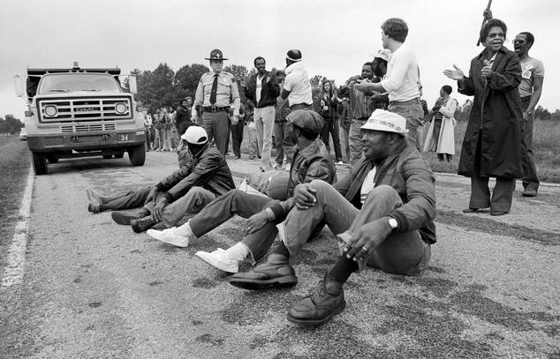
The photo shows Protestants blocking the delivery of toxic PCB waste to a landfill in Afton, North Carolin in the year 1982
Principles of Environmental Justice:
Environmental justice avows the holiness of Mother Earth, biological solidarity and reliance, all things considered, and the option to be liberated from environmental obliteration. Environmental justice also requests that the public approach be founded on common regard and justice for all people groups, liberated from any type of segregation or predisposition. It also commands the privilege to moral, adjusted, and mindful employments of land and inexhaustible assets in light of a legitimate concern for a maintainable planet for people and other living things. Additionally, environmental justice calls for general security from atomic testing, extraction, creation, and removal of harmful/perilous squanders and harms and atomic testing that undermines the major option to clean air, land, water, and food. The concept of environmental justice also confirms the key right to political, financial, social, and environmental self-assurance, all things considered. Environmental justice requests the discontinuance of the creation, everything being equal, perilous squanders, and radioactive materials, and that all past and current makers are considered stringently responsible to individuals for detoxification and the control at the place of creation, (Reese and Jacob, 2015).
Environmental justice also requests the option to take an interest as equivalent accomplices at each degree of dynamic, including needs appraisal, arranging, execution, authorization, and assessment. Environmental justice attests the privilege, everything being equal, to a protected and solid workplace without being compelled to pick between a perilous vocation and joblessness. It additionally asserts the privilege of the individuals who work at home to be liberated from environmental perils. The concept also secures the privilege of survivors of natural bad form to get full remuneration and repayments for harms just as quality medical services. Environmental justice considers administrative demonstrations of natural bad form an infringement of global law, the General Statement on Common freedoms, and the Unified Countries Show on Destruction. Environmental justice should perceive a unique legitimate and normal relationship of Local People groups to the U.S. government through arrangements, arrangements, compacts, and pledges avowing sway and self-assurance. It likewise attests to the requirement for metropolitan and provincial biological strategies to tidy up and revamp our urban areas and country territories in offset with nature, respecting the social trustworthiness of every one of our networks, and gave reasonable admittance to all to the full scope of assets.
Environmental justice requires the severe authorization of standards of educated assent, and an end to the testing of exploratory regenerative and operations and inoculations on minorities. Environmental justice goes against the dangerous tasks of worldwide companies. Environmental justice goes against military occupation, restraint and abuse of grounds, people groups and societies, and other living things. Environmental justice requires the instruction of present and people in the future which underscores social and environmental issues, in light of our experience and an enthusiasm for our assorted social points of view. Environmental justice necessitates that we, as people, settle on close to home and customer decisions to burn through as little of Mother Earth's assets and to create as minimal waste as could be expected; and settle on the cognizant choice to challenge and reprioritize our ways of life to guarantee the strength of the characteristic world for present and people in the future, (Banzhaf, et al, 2019).
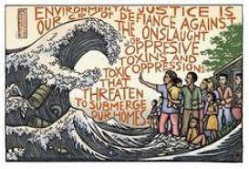
Environmental justice and eco-social justice: This photo was drawn to tell Canada’s leaders to redress environmental racism.
Barriers to Environmental Justice
Environmentalists first became popular in the early 20th century. The major focus of these environmentalists was on the protection of wilderness and the preservation of wildlife. This goal reflected on the needs of the environmental movements initiated by primarily white middle and upper-class environmentalists. This also included the preservation and protection of the environment through a lens that failed to grow the centuries-long work of native communities who had lived without leading in the types of environmental damage that these settler-colonial "environmentalists" now wanted to mitigate. The movements of many mainstream environmental organizations still reflect these early environmental values.
Initial barriers to the participation of minorities
Many low-income minorities were isolated or adversely affected by the environmental justice movement. Allies of economic development have taken benefit of environmentalists' disregard of minorities. They have persuaded minority pioneers hoping to improve their communities that the economic advantages of modern office and the increment in the number of occupations merit wellbeing chances. Indeed, the two government officials and organizations have even undermined inescapable occupation misfortune if communities don't acknowledge dangerous ventures and offices. Albeit by and large neighborhood occupants don't get these advantages, the contention is utilized to diminish opposition in the communities just as keep away from uses used to tidy up toxins and establish more secure work environment conditions. Therefore, several minorities have seen natural development as elitist. Environmental elitism showed itself in three distinct structures:
- Compositional: Earthy people are from the center and privileged.
- Philosophical: The changes advantage the development's allies yet force costs on nonparticipants.
- Effect: The changes have "backward friendly effects". They excessively advantage hippies and mischief underrepresented populaces.
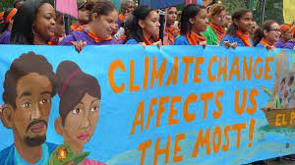
The intersection of social justice and environmentalism. This photo advocate for inclusivity in environmental justice since it affects all of us.
Decisions that cause environmental harm are frequently made either by nearby drafting sheets or by state environmental offices, as resident commissions. For instance, the nearby Arranging and Drafting Commission will choose where to site Locally Undesirable Land Uses (Humdingers), like landfills, squander incinerators, or manufacturing plants. State-selected bodies, for example, the Environmental Assurance Commission in my state, frequently choose inquiries of water or air contamination allowing and enforcement. State natural sheets likewise regularly experience the ill effects of an absence of variety. Frequently, state resolutions necessitate that specific monetary gatherings be addressed (e.g., industry or farming), however don't order portrayal for those affected by contamination. Neighborhood authorities should enroll drafting board members from underrepresented populaces, including those generally influenced by natural damages. Furthermore, state resolutions ought to be changed to guarantee satisfactory portrayal from affected low-pay and minority networks.
Cost barriers
One of the unmistakable barriers to minority cooperation in environmental justice is the underlying expenses of attempting to change the framework and keep organizations from unloading their harmful material and different contaminations in territories with high quantities of minorities living in them. There are gigantic legitimate charges associated with battling for environmental justice and attempting to shed environmental prejudice. For instance, in the Unified Realm, there is a standard that the inquirer may need to cover the expenses of their rivals, which further worsens any expense issues, particularly with lower-pay minority gatherings; likewise, the solitary path for environmental justice gatherings to consider organizations responsible for their contamination and breaking any authorizing issues over garbage removal issue the public authority for not upholding rules, (Edwards, et al, 2016). This would prompt the prohibiting legitimate expenses that most couldn't manage. This can be seen by the way that out of 210 legal survey cases somewhere in the range of 2005 and 2009, 56% didn't continue because of expenses.

This photo shows costs as a barrier to environmental justice
The issue of a fair process
To go against the siting of a thruway or manufacturing plant that will affect their area, minority, and low-pay bunches face various obstructions to mounting viable resistance. They ordinarily experience the ill effects of an absence of assets, restricted spare energy, and confined admittance to political organizations, (Di Chiro, 2016). Aggregate activity issues overload their endeavors to marshal assets to employ legitimate advice or master observers. Adding to their challenges, numerous states don't permit rivals of a natural license an ill-disposed hearing, along these lines keeping them from viably making a record at the managerial level. Making cooperation by affected networks simpler and more viable will require legal and administrative changes to regulatory hearing methods. Meanwhile, in any case, environmental lawyers ought to consider free freedoms to help level the playing field. These proposals address just two underlying issues lying behind the racial differences in environmental mischief.
Overcoming barriers to environmental Justice
Review their communities as lopsidedly affected by environmental debasement and excessively denied admittance to developments professing to change this, numerous associations by and for racialized communities and low-abundance bunches started to frame during the 1970s and 80s to address natural shameful acts. Their work has come to altogether frame the foundation of the contemporary environmental justice development, whose core values were particularly reported during the Main Public Ethnic minorities Natural Initiative Highest point in 1991. Participants in this Culmination set up 17 specific Standards of Environmental justice. To overcome the barriers to environmental justice, communities need to understand the benefits of green infrastructure. There is a need to develop pilot programs that will equip the community with knowledge and experience for developing and implementing environmental justice approaches, (Salem, 2019).
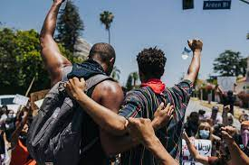
Racial justice and involvement of everyone in environmental justice
Overcoming the perceptions of higher costs in integrating the approaches to environmental justice requires the implementers and environmentalists to recognize the multiple benefits of environmental justice, which cover up for the costs. Environmental justice uses the limited public assets to give different advantages, including cleaner water, yet additionally cleaner air, higher property estimations, and more sporting freedoms. A developing number of districts have led to thorough money-saving advantage investigations exhibiting the potential for a green framework to offer more benefit than dark. Specialists need to analyze the economic factors that affect the decision of the environmentalists and green environment developers. Most developers look at the costs of implementing environmental justice approaches as minor compared to the numerous economic benefits underlying the decision to build these projects. This has facilitated the continued growth and success in achieving environmental justice, (Marion, 2015).
Ways to support environmental justice every day
Practice Self-Education
The initial phase in engaging and intensifying voices inside weak networks is self-education on the connections between underlying prejudice and the lopsided environmental risks found in oppressed networks. As well as finding out about the actual disparities, do some exploration on the nearby and government approaches that are intended to sustain those distinctions in any case. Furthermore, it is imperative to understand that even inside major environmental gatherings and non-benefits, the initiative will in general be working class and white. Be mindful so as not to aimlessly accept that these associations, policymakers, and pioneers are progressing natural justice for all. Look into their arrangements and drives to get a comprehension of whether the worries, needs, and voices of oppressed residents are on the plan. A fast Google search of "natural social justice " or "environmental prejudice" is a simple beginning to your self-training, on either ebb and flow unjust natural risks or policymaking, (Lasker, et al, 2017).

Children being taught environmental on environmental conservation in efforts to establish a generation that minds about environmental health and conservation.
Raise the Voices of the Affected People group
Whenever you've instructed yourself, become acquainted with the social justice advocates locally, and support them in any way you can. This help can take on a few structures. If it is possible for you, you can give straightforwardly to associations pushing for natural justice or loan your assistance as a volunteer. As the People of color Matter promotion, this late spring illustrated, online enhancement of voices and sharing of assets on whatever stage accessible to you can likewise be useful. Inside the Yale people group, preceded with the intensification of understudy exceed through Dwight Corridor or the Afro-American, Asian American, Latino, and Local American Social Places are significant, as well. Regardless of what road you choose to seek after, the need is to ensure these natural issues don't get lost in the commotion.
Consider Your Delegates Responsible
Past intensifying the voices of natural justice activists, it is imperative to look at the job that singular residents can play in destroying primary bigotry, in particular at the nearby level. Stay educated about the nearby environmental issues locally. At the point when issues come up concerning allowing and land use plans, strategy plan and authorization, and award grants advocate for these issues to be focused on and the choices concerning them to be made straightforward. To put it plainly, consider your local area and your agents responsible for their environmental votes! How about we all do our part to change the story that natural contemplations in our networks are lumbering; the enduring effect of early purposefulness is certainly worth our time, (Temper, et al, 2015).
Utilize the Force of Boycott
Considering your local area and public authorities responsible while not being deliberate about where you spend your dollars is irrational. Before you shop, examine the natural acts of enterprises. While numerous organizations have gotten progressively straightforward about their practices, intentional environmental damage in weak networks for financial addition is tragically ordinary, (Wiebe, 2016). Rather than exclusively depending on enormous organizations, think about putting your dollar in your nearby economy, for example, shopping locally for food supplies or purchasing straightforwardly from little or minority-possessed organizations. You will likely find a few pearls regardless of whether it is your new most loved ranchers' market or nearby gem dealer all the while!
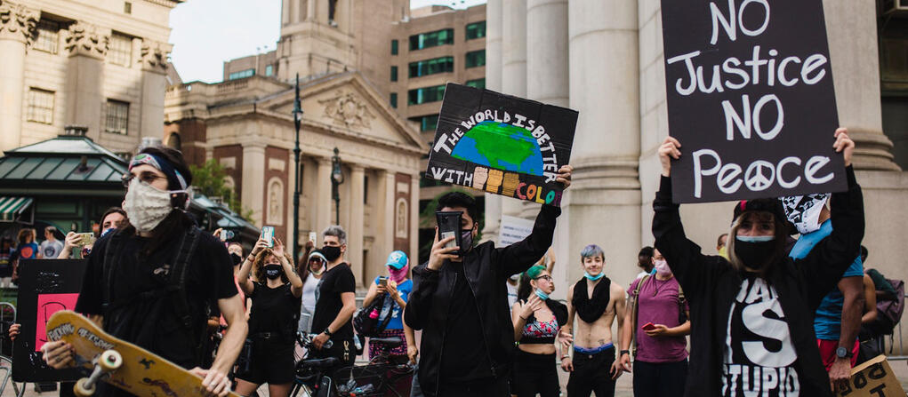
Advocates and allies in this fight for environmental justice
Conclusion
Environmental justice is a very important concept describing the struggle to improve and maintain a clean and healthy environment especially for those who have occasionally lived, worked, and played nearby to the sources of environmental pollution. Many grassroots environmental justice organizations have been established more than 20 years ago when the dump trucks started rolling into Afton, North, and Carolina. Currently, most of these organizations have become stronger and have created permanent forces to protect the environment and create social changes that benefit the communities, (Agyeman, et al, 2016).
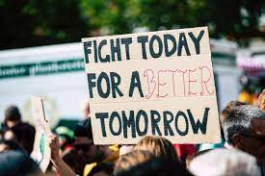
If we fight for environmental justice today, we will have a better environment to work, learn and live in tomorrow.
Bibliography
Martinez-Alier, J., Temper, L., Del Bene, D., & Scheidel, A. (2016). Is there a global environmental justice movement?. The Journal of Peasant Studies, 43(3), 731-755.
This article highlights the causes of the high number of environmental distribution conflicts all across the globe and how it is affecting the breakdown of the economy in terms of growing flows of energy and materials. It also sheds some light on the concepts and campaign slogans of the environmental justice movement such as environmental racism, popular epidemiology, the environmentalism of the poor and the indigenous; tree plantations are not forests, the environmental debt, climate justice, food sovereignty, and land grabbing and water justice, among other concepts.
Banzhaf, S., Ma, L., & Timmins, C. (2019). Environmental justice: The economics of race, place, and pollution. Journal of Economic Perspectives, 33(1), 185-208.
This article addresses the grassroots movement that took the issues of environmental justice to the national level. It also incorporates research documenting the correlation between pollution and race and poverty. This article has established unfair exposure to nuisances as a conventional fact of social science, specifically where it interconnects with work by economists. It argues that additional research is required to realize how much weight to give environmental justice mechanism. The article also discusses some policy options at the end.
Temper, L., Del Bene, D., & Martinez-Alier, J. (2015). Mapping the frontiers and front lines of global environmental justice: the EJAtlas. Journal of Political Ecology, 22(1), 255-278.
This article features the requirement for synergistic exploration of environmental struggles from a worldwide point of view. As the social digestion of our mechanical economy increments, increasing extractive exercises and the creation of waste, the connected social and natural effects produce clashes and opposition across the world. This extension of worldwide private enterprise prompts more prominent disengagement between the assorted topographies of the bad form along ware chains.
Lasker, G. A., Mellor, K. E., Mullins, M. L., Nesmith, S. M., & Simcox, N. J. (2017). Social and environmental justice in the chemistry classroom. Journal of Chemical Education, 94(8), 983-987.
This article emphasizes the need for education in the field of environmental justice. Despite advances in dynamic learning instructional methods and different strategies intended to expand understudy commitment in the science homeroom, maintenance and commitment give endure, especially as for ladies and minorities underrepresented in STEM (science, innovation, designing, and arithmetic) programs. Significance likewise stays tricky in the science study hall, where genuine issues of social justice, wellbeing, and the climate are generally absent from science educational plans. Therefore, understudies battle to comprehend their job as change specialists and worldwide residents with authority duty toward creating answers for these justice issues, especially as they identify with science and assembling ventures.
Agyeman, J., Schlosberg, D., Craven, L., & Matthews, C. (2016). Trends and directions in environmental justice: From injustice to everyday life, community, and just sustainabilities. Annual Review of Environment and Resources, 41.
This article starts with a survey and blends a portion of the key speculations, researchers, case models, discussions, strategies, and (different) understandings of environmental justice (EJ), just as its extension and globalization. It also at a point looks to some recently arising subjects, activities, and systems for EJ and just manageable qualities. To begin with, it takes a gander at the practices and materials of regular day to day existence, represented by food and energy developments; second, the progressing work on the local area and the significance of personality and connection, educated by metropolitan arranging, food, and environment concerns; third, the developing interest in the connection between human practices and networks and nonhuman nature. It additionally develops the longstanding premium in only manageable qualities inside this development, delineated by a wide scope of worries with food, energy, and environmental justice. These new spaces of work outline both ongoing turns of events and a bunch of ways ahead for both the hypothesis and practice of EJ.
Reese, G., & Jacob, L. (2015). Principles of environmental justice and pro-environmental action: A two-step process model of moral anger and responsibility to act. Environmental Science & Policy, 51, 88-94.
This article recommends that convictions about environmental justice are a significant angle in the ability to constantly focus on favorable to natural practices and activities both on individual and cultural levels. Since environmental strategy is dependent upon choices across different state establishments, the current article centers around three standards of natural justice convictions and tests their autonomous commitments toward favorable to environmental conduct. It additionally centers around two potential cycles that may clarify the connection between justice convictions and favorable to natural conduct, in particular, moral outrage and saw duty. Following assumptions, more grounded environmental justice convictions anticipated supportive of natural aims.
Salem, H. S. (2019). No sustainable development in the lack of environmental justice. Environmental Justice, 12(3), 140-157.
This article defines environmental justice as the involvement of the entire community in the development, implementation, and enforcement of environmental rules and regulations without any form of discrimination. This article reveals insight into the issues of environmental justice (foul play) and economical (unreasonable) improvement in the Select, considering the Israeli infringement of global law and worldwide deals, just as the neighborhood and local arrangements identified with the climate. Taking into account the abovementioned, the article recommends certain standards of environmental justice which ought to be generally confirmed and embraced.
Di Chiro, G. (2016). 31. Environmental Justice. In Keywords for Environmental Studies (pp. 100-105). New York University Press.
Despite the extended cleavages between the currents of environmentalists, this article gives hope of a confluence among the conservationists and the many people concerned with the injustices of climate change through pushing for environmental debts, promoting technological changes, and support towards green energy. The article also highlights that the quest for environmental justice is a moral struggle for human rights and a social-political concept that when not well looked at can cause economic and environmental degradation.
Marion Suiseeya, K. R. (2015). Displacing difference and the barriers to environmental justice. Politics, Groups, and Identities, 3(4), 697-702.
This article gives a significant commitment to our comprehension of environmental justice: it addresses existing discussions on the multidimensional idea of justice while likewise contributing new experiences into boundaries to natural justice. Specifically, the articles represent how investigations of environmental justice cases that take care of distinction in needs, limits, personalities, perspectives, and standards can help researchers, specialists, and strategy producers explore natural justice claims. Maybe above all, these cases cause us to notice the various roads through which contrast is dislodged moved, moved, or eliminated from the dynamic space making different pathways to environmental treachery. This assortment delineates how investigations outlined through a multidimensional focal point can catch such components of justice and bad form.
Edwards, G. A., Reid, L., & Hunter, C. (2016). Environmental justice, capabilities, and the theorization of well-being. Progress in Human Geography, 40(6), 754-769.
This article addresses how environmental justice (EJ) scholarship is progressively outlining justice regarding abilities. This paper contends that capacities are generally about prosperity and as such, there is a need to all the more expressly speculates prosperity. It also investigates how abilities have come to be powerful in EJ and how prosperity has been drawn closer so far in EJ explicitly and human geology all the more extensively. It also presents a group of writing from social brain science which has wrestled hypothetically with inquiries concerning prosperity, utilizing the bits of knowledge we acquire from it to consider some potential directions and difficulties for EJ as it draws in with prosperity.

Reference
Martinez-Alier, J., Temper, L., Del Bene, D., & Scheidel, A. (2016). Is there a global environmental justice movement?. The Journal of Peasant Studies, 43(3), 731-755.
Banzhaf, S., Ma, L., & Timmins, C. (2019). Environmental justice: The economics of race, place, and pollution. Journal of Economic Perspectives, 33(1), 185-208.
Temper, L., Del Bene, D., & Martinez-Alier, J. (2015). Mapping the frontiers and front lines of global environmental justice: the EJAtlas. Journal of Political Ecology, 22(1), 255-278.
Lasker, G. A., Mellor, K. E., Mullins, M. L., Nesmith, S. M., & Simcox, N. J. (2017). Social and environmental justice in the chemistry classroom. Journal of Chemical Education, 94(8), 983-987.
Agyeman, J., Schlosberg, D., Craven, L., & Matthews, C. (2016). Trends and directions in environmental justice: From injustice to everyday life, community, and just sustainabilities. Annual Review of Environment and Resources, 41.
Reese, G., & Jacob, L. (2015). Principles of environmental justice and pro-environmental action: A two-step process model of moral anger and responsibility to act. Environmental Science & Policy, 51, 88-94.
Salem, H. S. (2019). No sustainable development in the lack of environmental justice. Environmental Justice, 12(3), 140-157.
Di Chiro, G. (2016). 31. Environmental Justice. In Keywords for Environmental Studies (pp. 100-105). New York University Press.
Wiebe, S. M. (2016). Everyday exposure: Indigenous mobilization and environmental justice in Canada’s chemical valley. UBC Press.
Marion Suiseeya, K. R. (2015). Displacing difference and the barriers to environmental justice. Politics, Groups, and Identities, 3(4), 697-702.
Edwards, G. A., Reid, L., & Hunter, C. (2016). Environmental justice, capabilities, and the theorization of well-being. Progress in Human Geography, 40(6), 754-769.

